**SYSTEM SECURITY**

**LAB 2**

**P.R.N:** 20190802058

**Name:** Krushal Milan Shah

**Experiment:**

1) Write C/C++/Python/JAVA program to implement Playfair cipher substitution technique.

2) Write a C/C++/Python/JAVA program to decrypt a ciphertext using Vigenere substitution technique. Consider following information for decipherment.

**Results:**

**1**

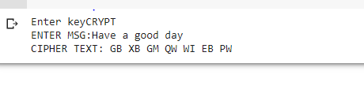

**2**

